

|  |  |
| --- | --- |
| Date | **27 April 2023** |
| Team ID | **NM2023TMID02092** |
| Project Name | Tracing the Growth of the Global community: **A**  **Population Forecasting Analysis** |
| Team Leader | **DEVIPRIYA. R** |
| Team Member | SWATHI. V |
| ANITHA. E |
| GAYATHRI. B |

1. INTRODUCTION

1.1 INTRODUCTION :

A population projection gives a picture of what the future size and structure of population by sex and age might look like. It is based on knowledge of past trends and for the future, on assumptions made for three components: fertility, mortality and migration.

**2. Empathy map and Ideation & Brainstorming:**

**2.1 Empathy Map**

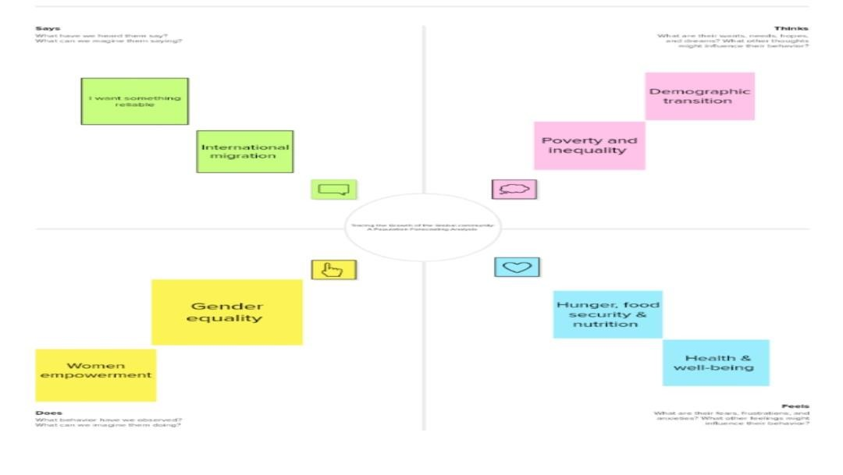

# 2.2 Ideation & Brainstorming Map

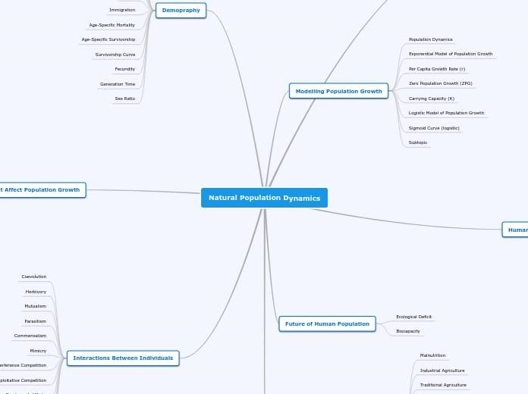

***Milestone 2:***

**Data Collection & Extraction from DatabaseData collection is the process of gather**

**Activity 1: Collect the dataset**

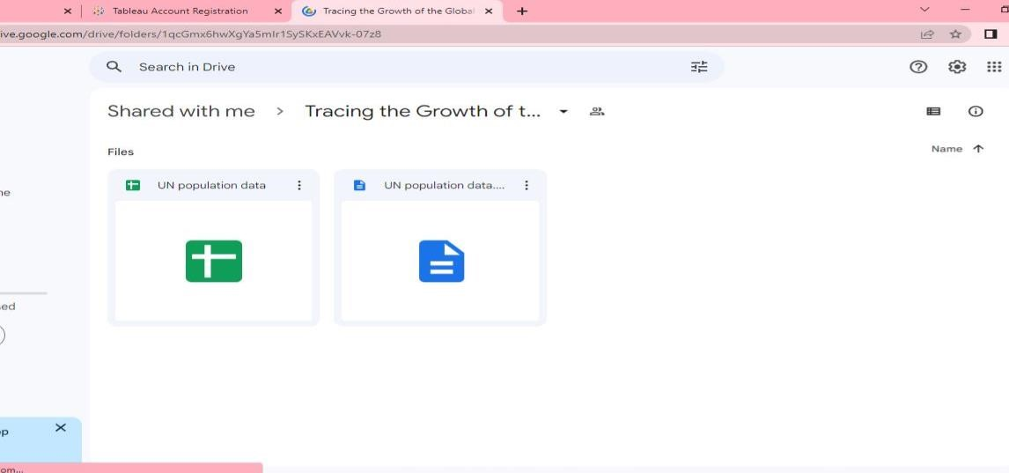

**Activity 1.1: Understand the data**

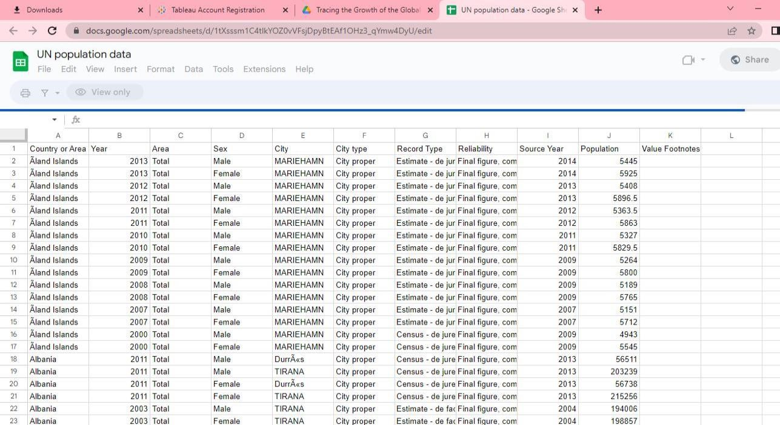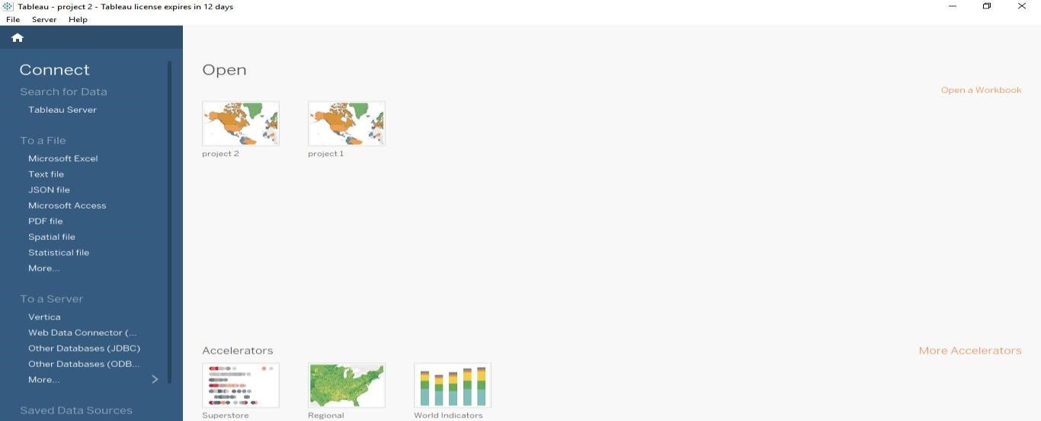

# Activity 2: Storing Data in DB & Perform SQL Operations

**Activity 3: Connect DB with Tableau:**



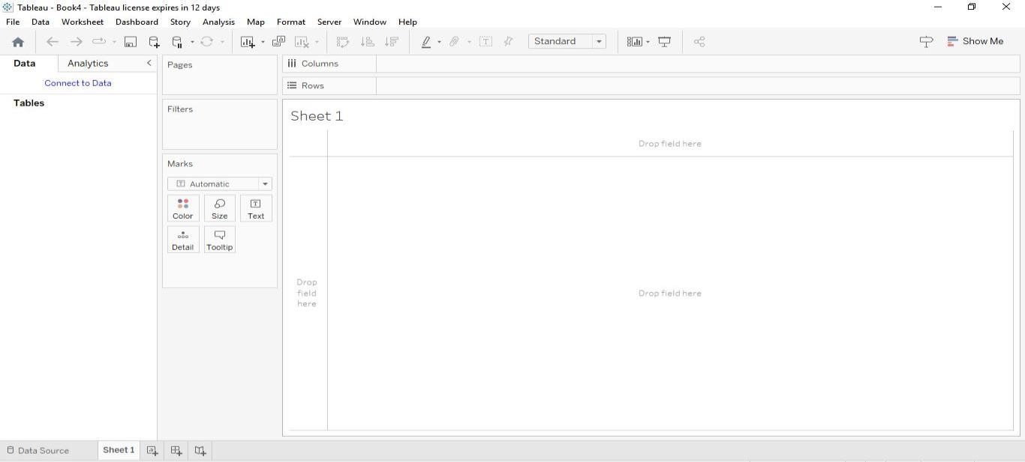

**Milestone 3:**

**Activity 1: Prepare the Data for Visualization**

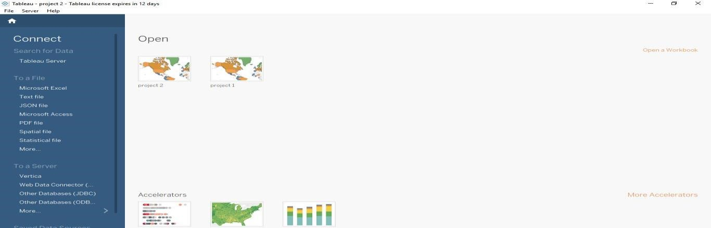

**Milestone 4:**

**Activity 1.1: Population records by type of countries Explanation:**

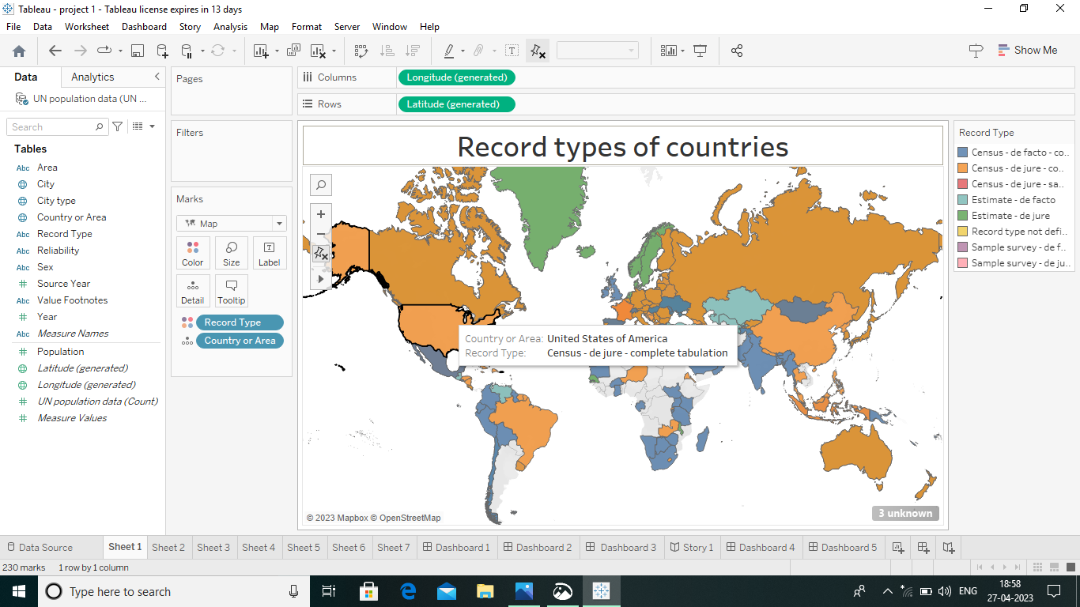

**Activity 1.2: Population trends over the years:**

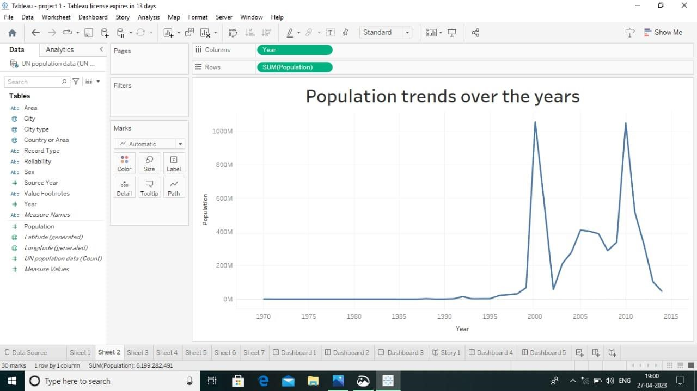

**Activity 1.3: Population trends over the years by sex**

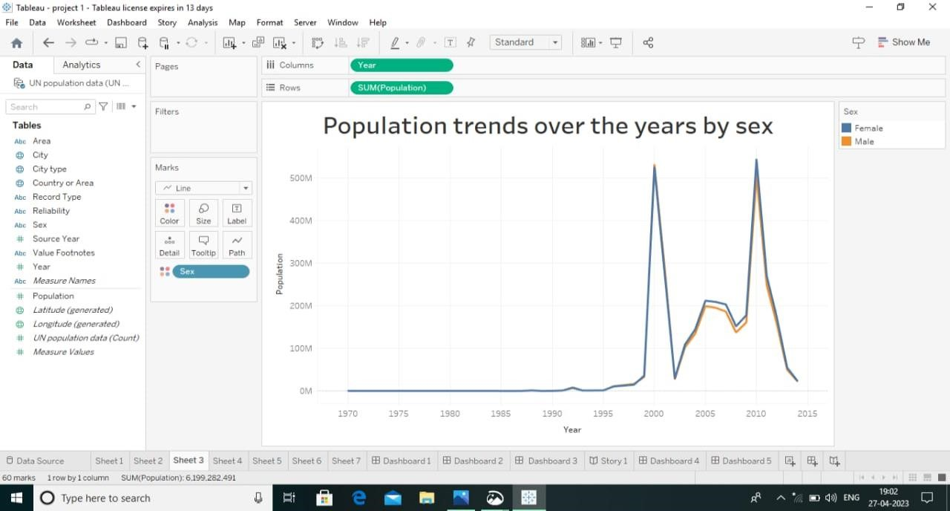

**Activity 1.4: Cities with highest average populations:**

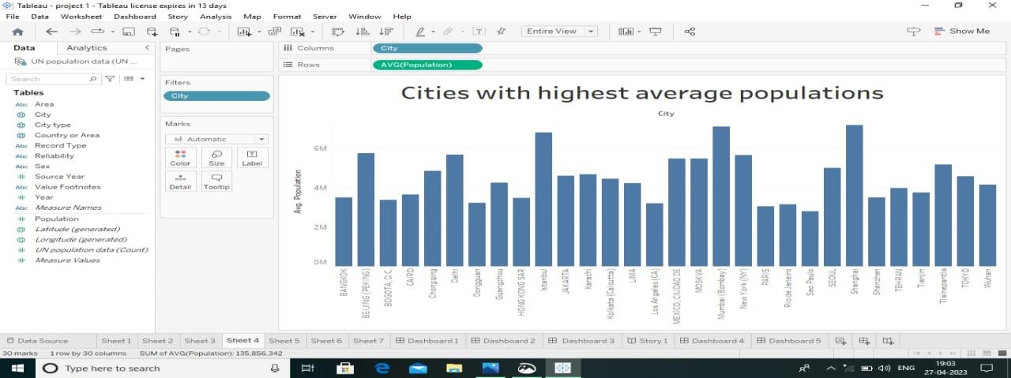

**Activity 1.5: Countries with highest average population from 2000-**

**2014**

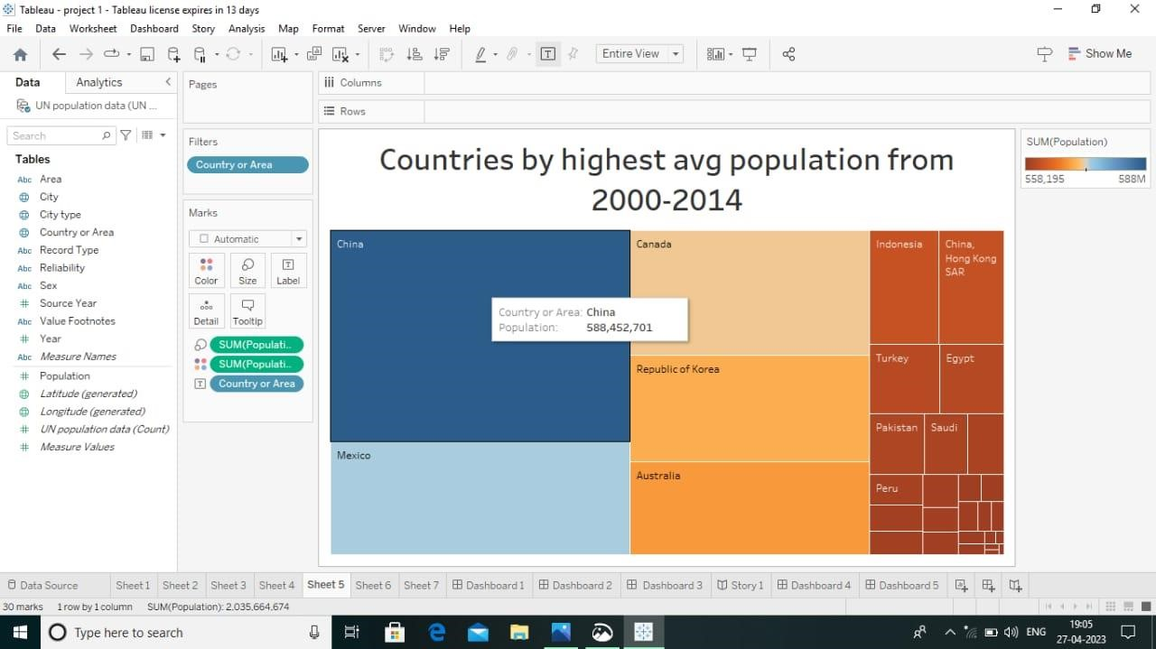

.

**Activity 1.6: Population by city type:**

.

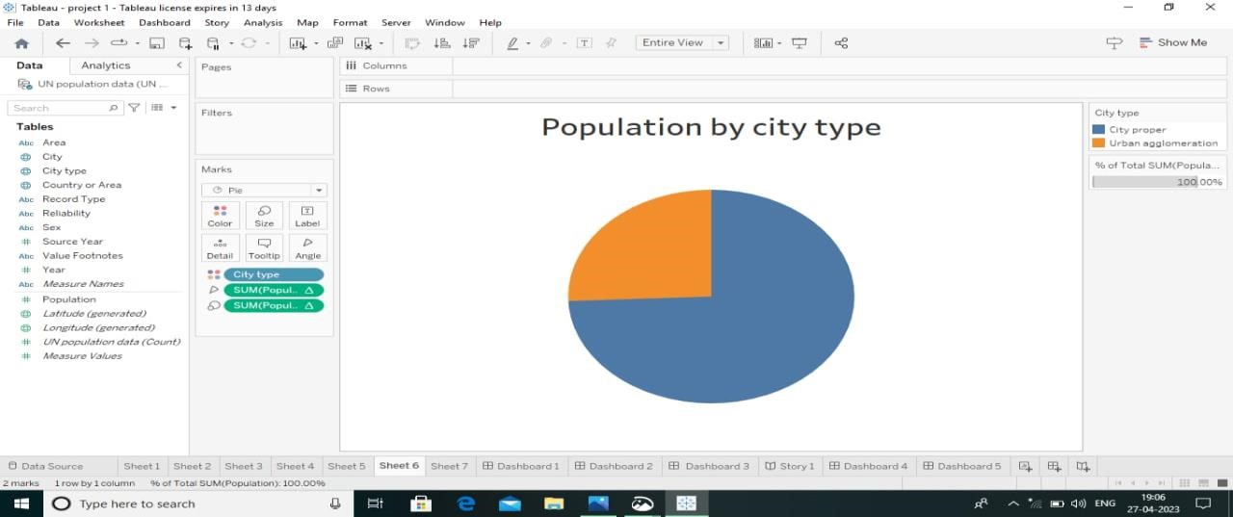

**Activity 1.7: Population of citied by year:**

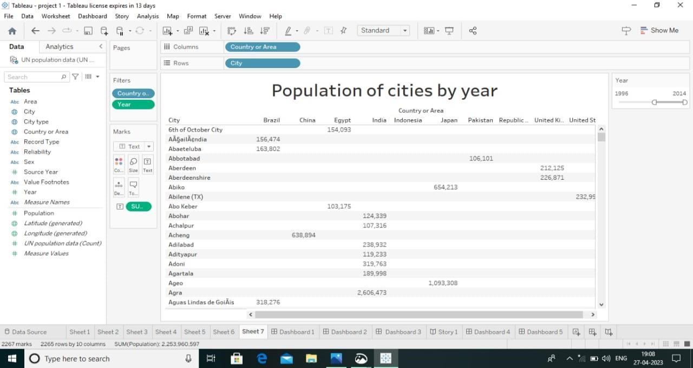

**Milestone 5:**

**Activity :1- Responsive and Design of Dashboard:**

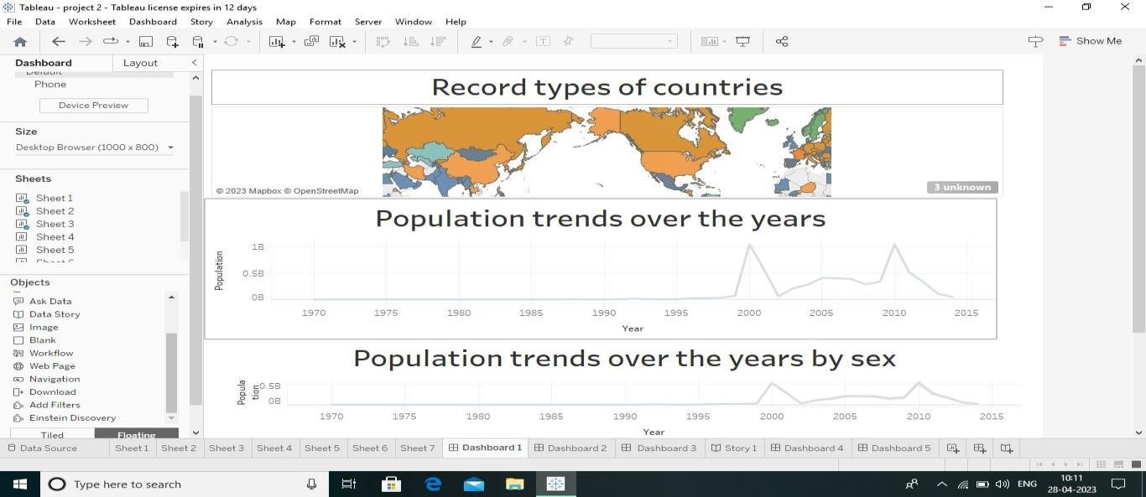

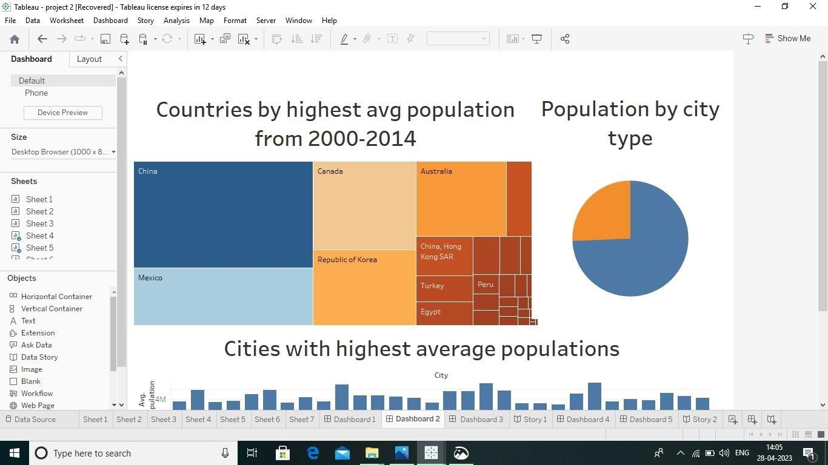

**Milestone 6:**

**Activity:1- No of Scenes of Story**

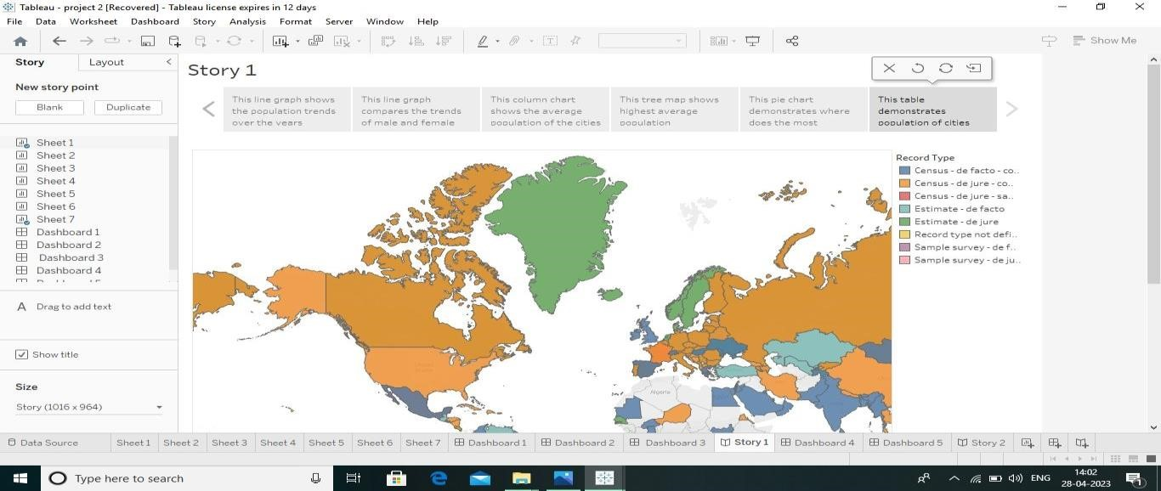



**Milestone 7:**

**Activity 1: Amount of Data Rendered to DB**

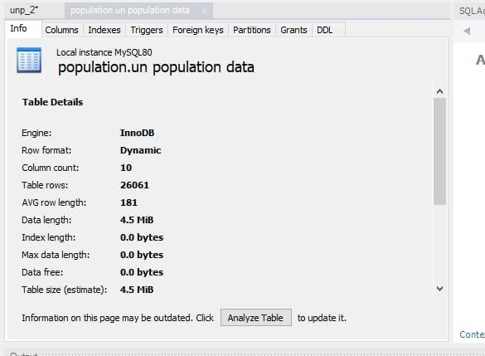

**Activity 2: Utilization of Data Filters:**

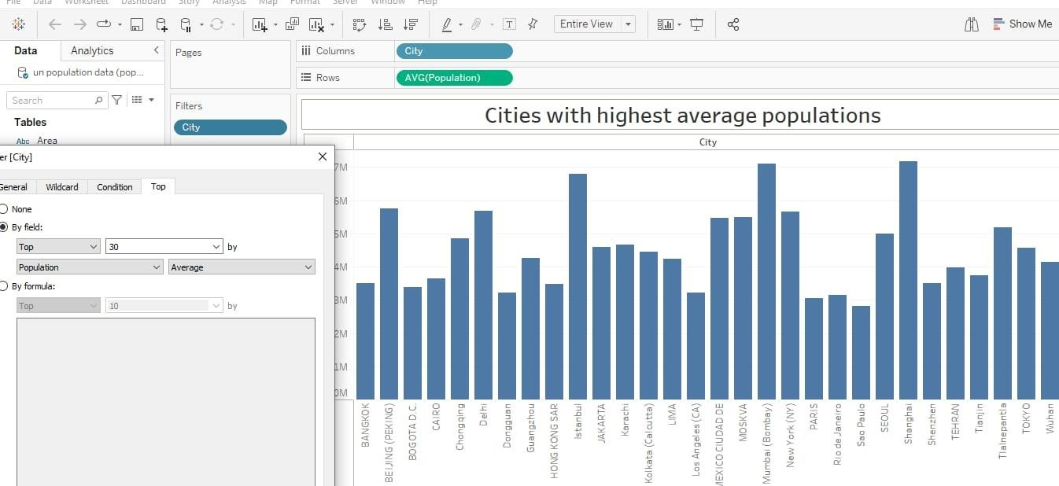

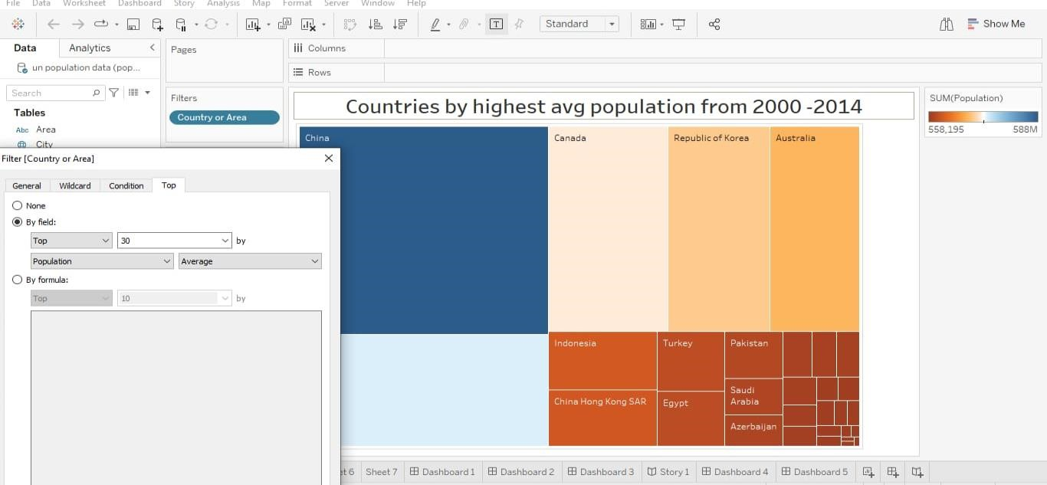

**Activity 4: No of Visualizations/ Graph**

1. **Population record types of countries**
2. **Population trends over the years**

# 3.Population trends over the years by sex

# 4. Cities with highest average population

# 5. Countries with highest avg population from 2000 – 2014

# 6. Population by city type

# 7. Population of cities by year

**Milestone 8:**

**Publishing dashboard and reports to tableau public Step**

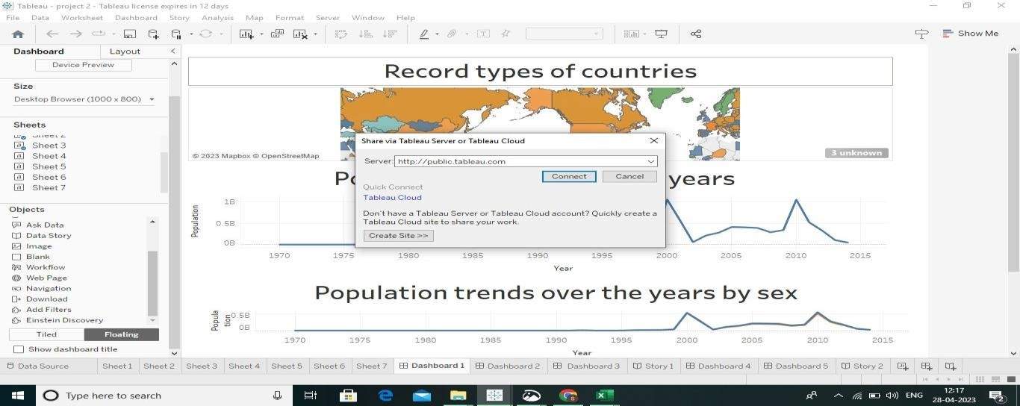

**Activity 1: Dashboard and Story embed with UI with flask:**



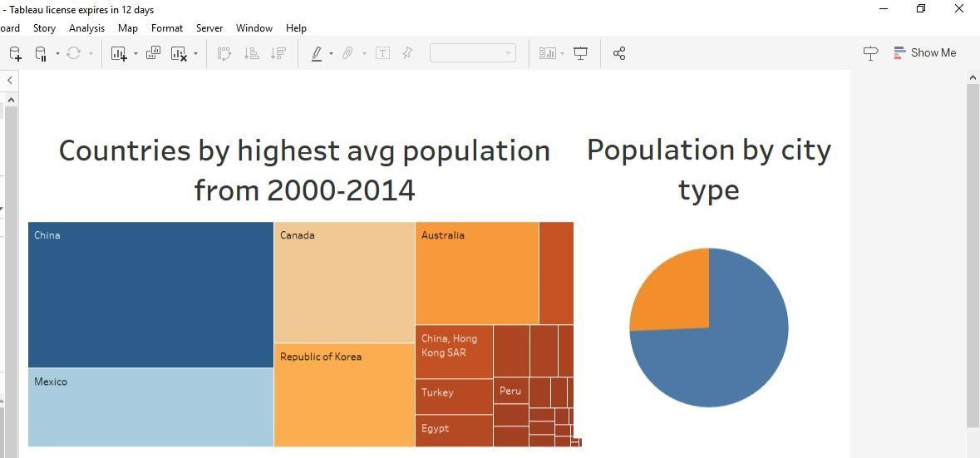

**CONCLUSION:**

**The world population is expected to grow with a probability of 95 percentage to about 10 to 20 billion by 2050.**

# Thank you